MSTR Issue :

Issue 1:Count of the ‘#Total Devices metric data is not matched with MSD and Redshift.

SELECT a.sys_class_name,

Count(1) as CNT

FROM png_mdsdb.cmdb_ci_final a

Where a.sys_class_name IN ('cmdb_ci_hardware','cmdb_ci_storage_device','cmdb_ci_voice_hardware')

AND a.cdctype<>'D'

group by 1;

redshift :

Select b.sys_class_name_c,count(1)

FROM ldb.f_configuration_item a

JOIN ldb.d_configuration_item b ON a.configuration_item_key=b.row_key

WHERE b.sys_class_name_c IN ('cmdb_ci_hardware','cmdb_ci_storage_device','cmdb_ci_voice_hardware')

group by 1;

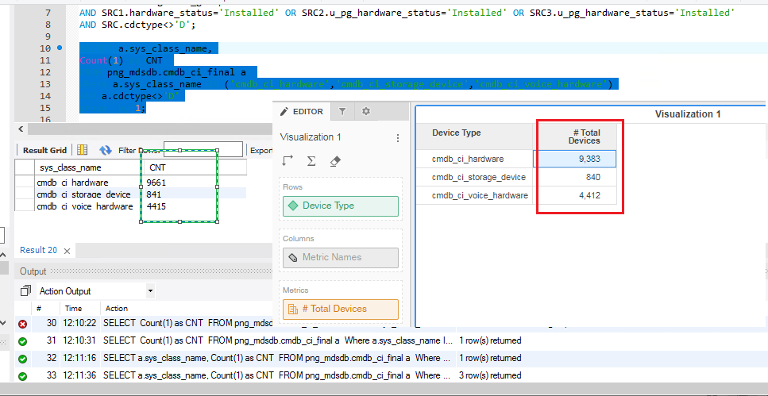

Issue 2: Noticed UNKNOW and UNSPECIFIED in the Hardware Status with 0 metric data :

UNKNOWN should not be displayed and Unspecified should display the respective value.

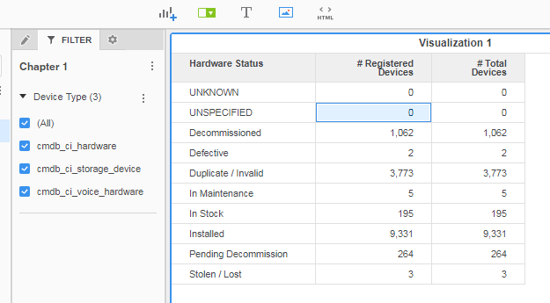

Issue 3: ‘# Active Devices’ metric data is not matching with MDS:

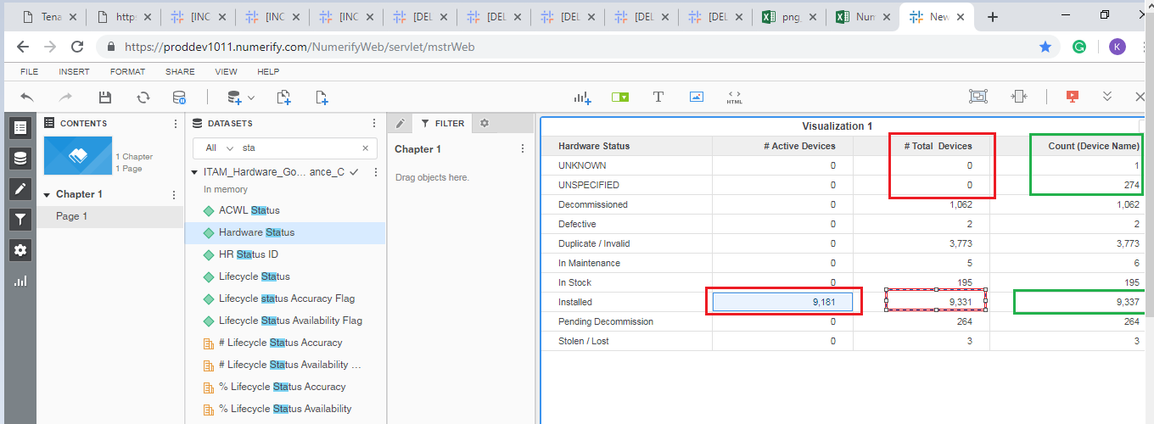

Issue 4: Hardware is having ‘UNKNOWN’

SELECT SRC.name,SRC.sys_class_name,SRC1.hardware_status

FROM png_mdsdb.cmdb_ci_final SRC

LEFT JOIN png_mdsdb.cmdb_ci_hardware_final SRC1 ON SRC.sys_id=SRC1.sys_id AND SRC.sourceinstance=SRC1.sourceinstance

LEFT JOIN png_mdsdb.cmdb_ci_storage_device_final SRC2 ON SRC.sys_id=SRC2.sys_id AND SRC.sourceinstance=SRC2.sourceinstance

LEFT JOIN png_mdsdb.cmdb_ci_voice_hardware_final SRC3 ON SRC.sys_id=SRC2.sys_id AND SRC.sourceinstance=SRC2.sourceinstance

WHERE SRC.name='mp181hq8-w10'

AND SRC.cdctype<>'D';

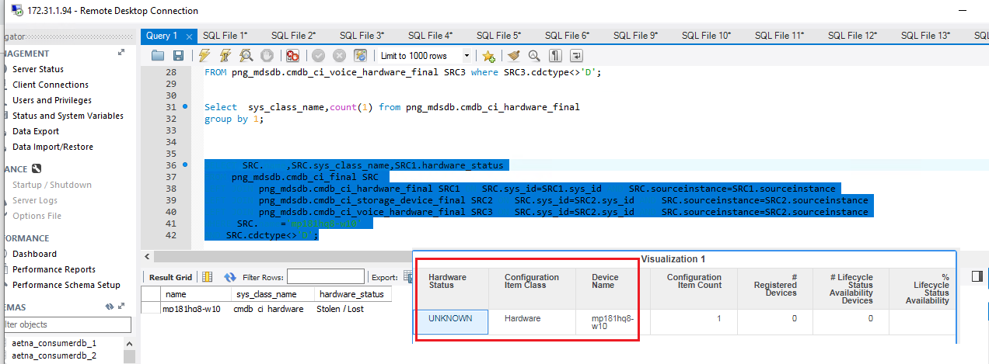

Issue 5: count of registered devices data is not matched

SELECT

Count(1) as CNT

FROM png_mdsdb.cmdb_ci_final SRC

LEFT JOIN png_mdsdb.cmdb_ci_hardware_final SRC1 ON SRC.sys_id=SRC1.sys_id AND SRC.sourceinstance=SRC1.sourceinstance

LEFT JOIN png_mdsdb.cmdb_ci_storage_device_final SRC2 ON SRC.sys_id=SRC2.sys_id AND SRC.sourceinstance=SRC2.sourceinstance

LEFT JOIN png_mdsdb.cmdb_ci_voice_hardware_final SRC3 ON SRC.sys_id=SRC2.sys_id AND SRC.sourceinstance=SRC2.sourceinstance

WHERE SRC.assignment_group iS NOT NULL

AND SRC.cdctype<>'D';

Issue 6: ‘# Managed Devices’ metric is displaying 0

Clarification needed, as the Metric is resulting 0,(is it tenable source)?

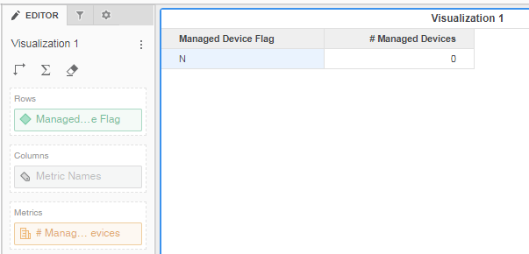

Issue 7: Organization Manager Details and Owned By Details are displaying the ID from and not mentioned in Design Document

